

FORM FILLER

Form Filler is a tool which allows you to enter data into a form with a tab delimited text file CSV. (CTRL + M To start) (CTRL + P To Pause)

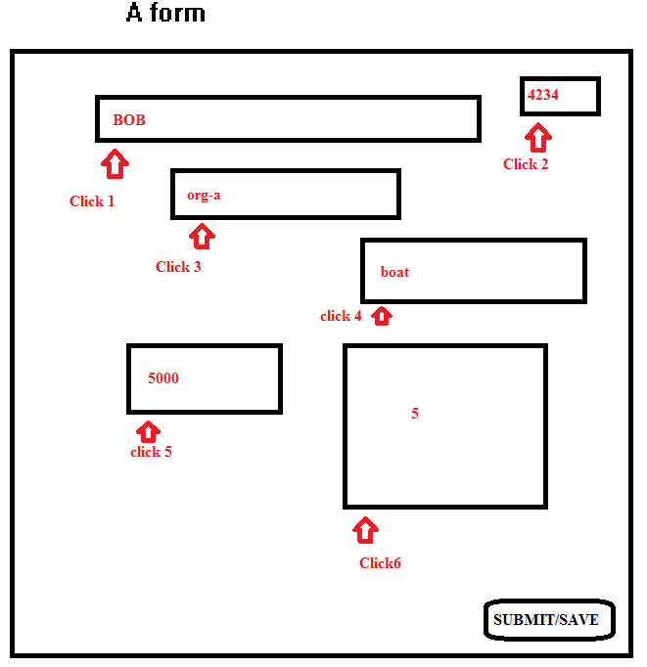

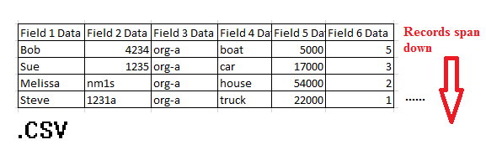

Form Filler uses 4 files FormFiller.ahk, DataIN.txt and DataOUT.txt and a spreadsheet you provide. Form filler also requires ahk installed and the AHK active window spy to get screen coordinates.



To get started open a spreadsheet with the data you want to import. Copy and select the data you want not including headers. (Note: all fields must be populated or this will not work)

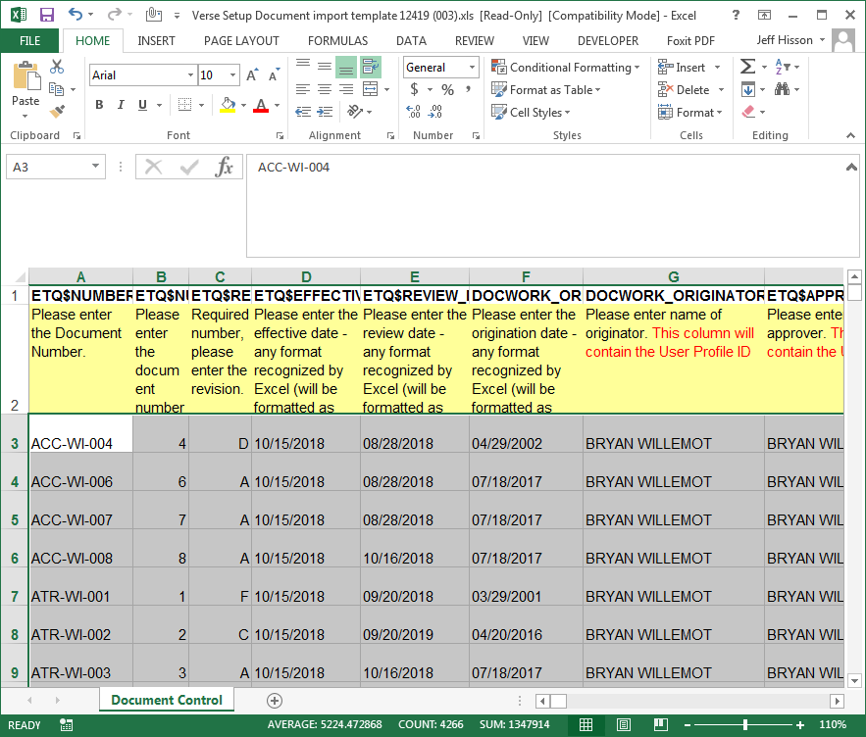

Paste the selected data into the empty file “DataIN.TXT” save and close DataIN.TXT

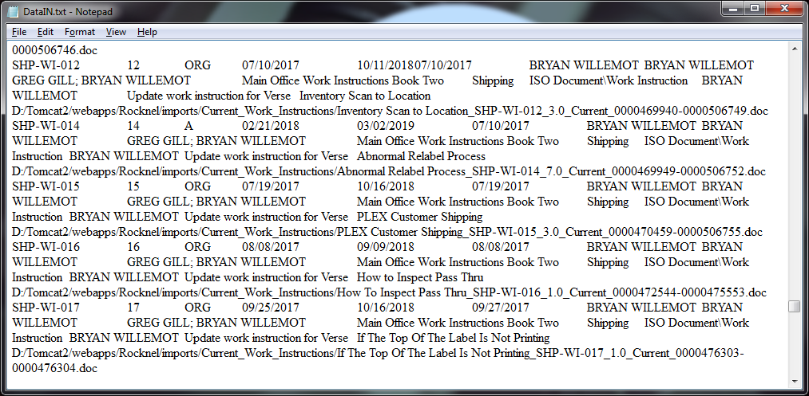

Right Click and EDIT “FormFiller.AHK”

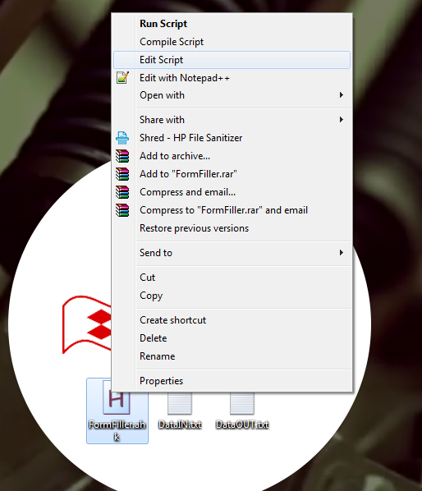

That should pull up some text which you can edit.

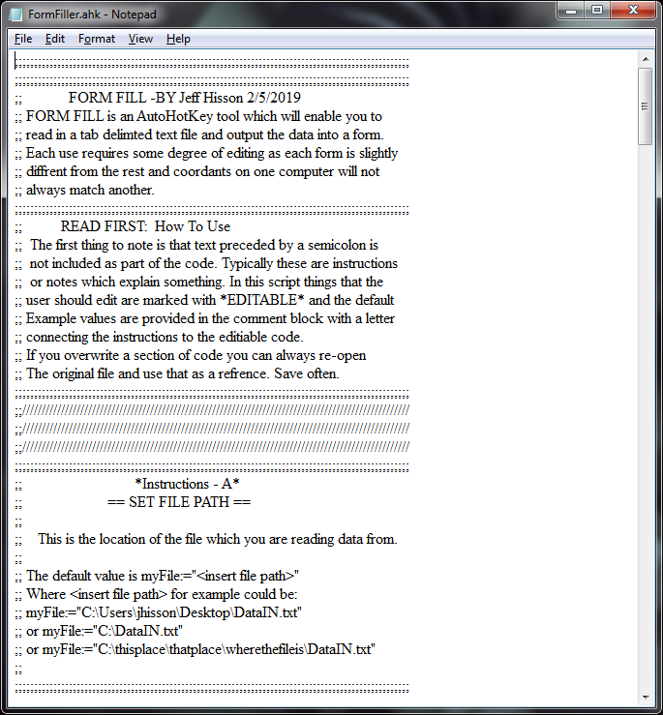

Each section has a set of instructions and an area marked for EDITING.

Here is a short summary:

Instructions – A : Setting a file path *Here you can see where to add a source path*

Instructions – B: Create arrays for each Column *this allows you to create variables which will output your source data*

Instructions – C: Config tools to assure page is loaded between inputs

Instructions – D: Post Data to FORM *area where blocks of actions can be described to post data to a form

Instructions – F : Creates an output file with the data that has been entered at the end of each loop

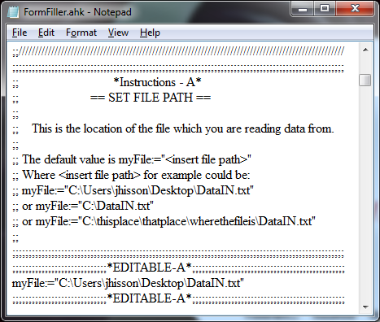

This section is pretty simple. Just write in the location of your source data file created earlier in the instructions using the format described here.

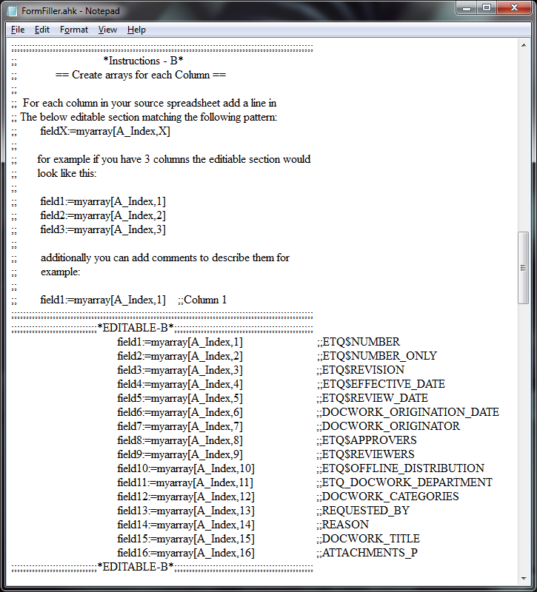

This section states that per column in your source spreadsheet you need a variable. By adding 1 line of

“fieldX:=myarray[A_Index,X]”

Per column you wish to put to the form you can later use the variable %fieldX% where x is the number of the column you wish to use to send that data.

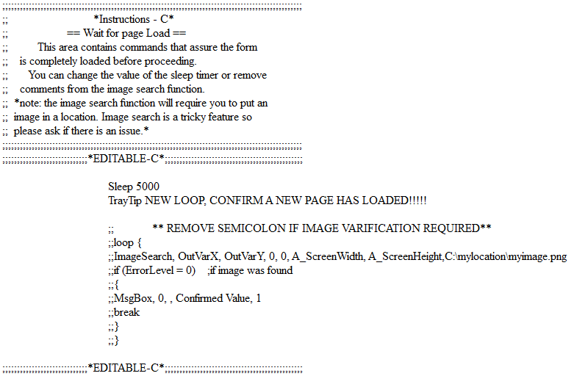

Section C exists to force a delay and assure the form has loaded

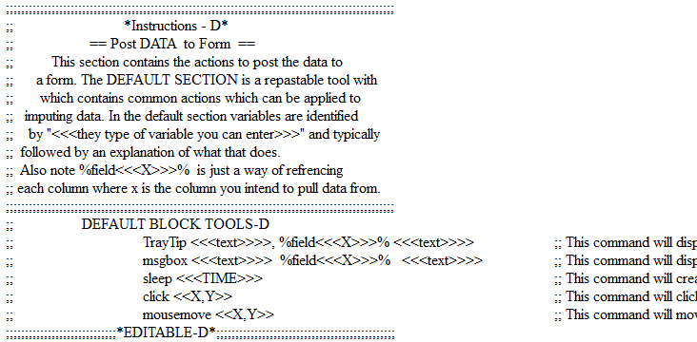

Section D is a bit more involved. For each column you intend to write data from you will create a block of actions which take place which mirror your actions as if you would have done them in real life.

For example in this graphical entry you click 6 times and then submit.



The blocks would look like this:

Click 200,150 ;; Moves to form location

Send %field1% ;; Enters BOB

Msgbox Check your entry ;; Asks user to check the entry

Click 800,100 ;; Moves to form location

Send %field2% ;; Enters 4234

Msgbox Check your entry ;; Asks user to check the entry

Click 250,200 ;; Moves to form location

Send %field3% ;; Enters org-a

Msgbox Check your entry ;; Asks user to check the entry

Click 600,350 ;; Moves to form location

Send %field4% ;; Enters boat

Msgbox Check your entry ;; Asks user to check the entry

Click 220,600 ;; Moves to form location

Send %field5% ;; Enters boat

Msgbox Check your entry ;; Asks user to check the entry

Click 600,600 ;; Moves to form location

Send %field6% ;; Enters boat

Msgbox Check your entry ;; Asks user to check the entry

Click 800,800 ;; Hits Submit/Save

It’s key to note these blocks change based on the shape of the form. *Traytips can be added but are not required*

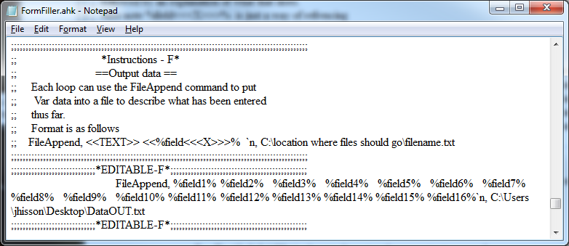

Section F

is optional and simply allows the user to create an output file for what was entered. This is useful if you are entering many files and wish to take a break. The file append command will write the contents of variables to a file in the location of your choosing. If you do not wish to have a file output simply add a colon “;” in front of the file append command and this section of code will not execute.

A demo can be seen here:

<https://youtu.be/23qGygRlvA4>